***CLASS A GYMNASIUM – COMMUNICATION SKILLS***

***Look at the following statements and choose the correct response:***

1. **– Are there any empty cups left?**
2. **-No, sorry, there aren’t any.**
3. [](https://png.clipart.me/previews/744/green-shopping-bag-45376.png)**-Yes, thank you.**
4. **-Where do you live?**
5. **– I live in Athens.**
6. **– I like living there.**
7. **-Can I borrow your pen?**

**a.-Yes, ok.**

**b.-Thank you.**

**4. -Is there a computer in the study?**

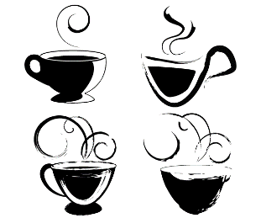 **a. – Oh, all right.**

**b.- Yes, there is.**

**5. -Here you are.**

**a.- Goodbye.**

**b.- Thanks very much.**

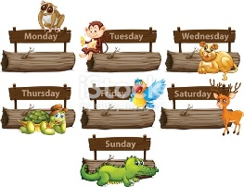**6. – What do you think?**

**a. – Here you are.**

**b.- It’s great.**

**7. -Where is Polly’s bag?**

**a. It’s under the chair.**

**b. – She needs it.**

**8.- Is there a television in your room?**

**a. It’s fantastic.**

**b. Yes, there is .**

**9. – When is your next English test?**

 **a. – It’s on Thursday.**

**b. – It’s in Thursday.**